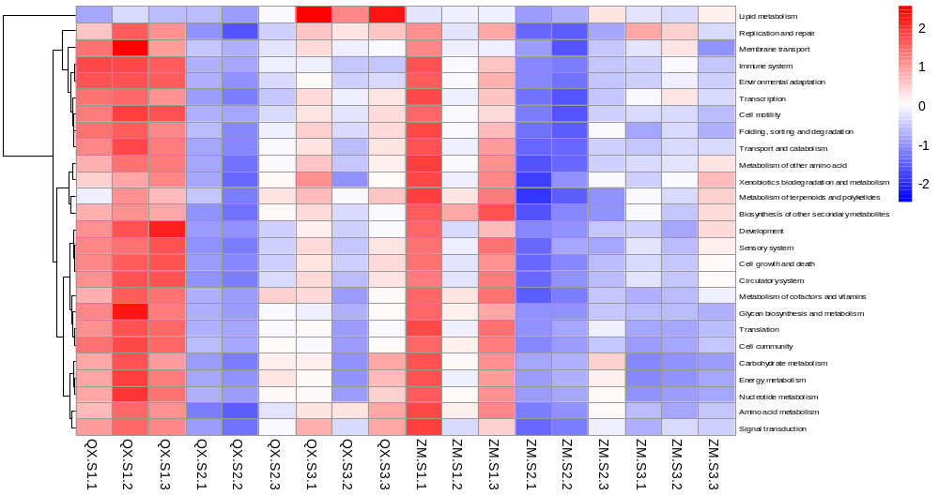
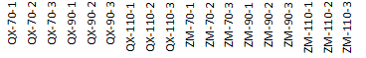
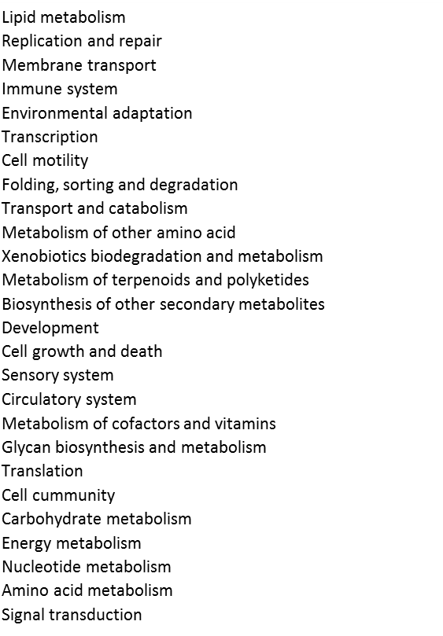

Figure S1 Clustering analysis (heatmap) of annotations for metabolic pathways. Red indicates high gene expression level; white indicates medium level and blue indicates low activity. KEGG categories were labled in the right of each heatmap line.

